Assignment 2

<html>

<head>

<title>Sum,Diff and Prod</title>

</head>

<body>

<script type="text/javascript">

var a, b, sum, diff, product;

a = parseInt(prompt("Please enter the number: "))

b = parseInt(prompt("Please enter the number: "))

sum =a + b

diff = a- b

product = a \* b

document.write("the sum of " + a + "and" + b +" is= "+sum +"<br>")

document.write("the diff of " + a + "and" + b +" is= "+ diff +"<br>")

document.write("the product of " + a + "and" + b +" is= "+ product +"<br>")

</script>

</body>

</html>

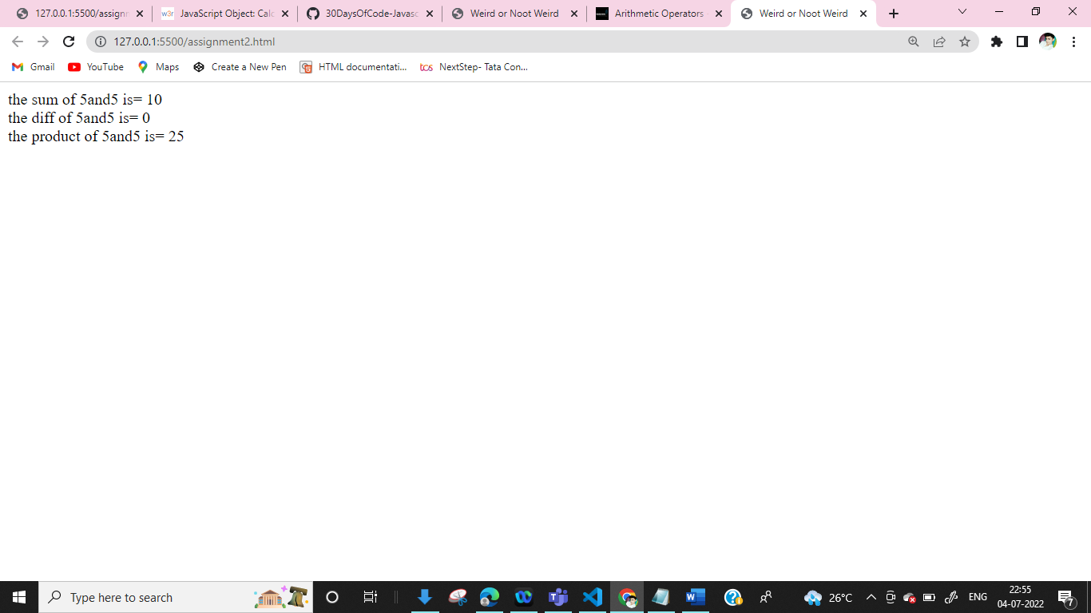

Assignment 3

<html >

<head>

<title>Document</title>

</head>

<body>

<script type="text/javascript">

var num1,num2,res,res1

num1=parseFloat(prompt("Enter a Nos:"))

num2=parseFloat(prompt("Enter a Nos:"))

res=num1%num2

res1=num1/num2

document.write("the remainder of " + num1 + "and" + num2 +" is= "+res +"<br>")

document.write("the quotient of " + num1 + "and" + num2 +" is= "+ res1 +"<br>")

</script>

</body>

</html>

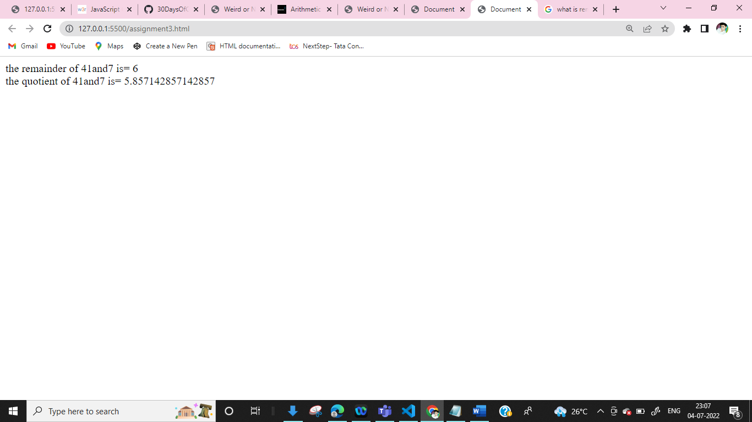

Assignment 4(Doubt)

<html >

<head>

<title>Leap Year</title>

</head>

<body>

<script>

var n

n=parseInt(prompt("Enter a Year:"))

if(n%4==0)

{

alert(n+"is a leap year")

}

else if(n%100==0)

{

alert(n+"is not a leap year")

}

else if(n%400==0)

{

alert(n+"is a leap year")

}

</script>

</body>

</html>

Assignment 5

<html >

<head>

<title>for loop</title>

</head>

<body>

<script>

var num,i,j

num=parseInt(prompt("Enter a nos"))

i=1;

for(j=2;j<=10;j++)

{

document.write("i:",i,"j:",j+"<br><br>")

document.write(i,"/",j+"<br><br>")

document.write(i/j+"<br><br>");

}

</script>

</body>

</html>

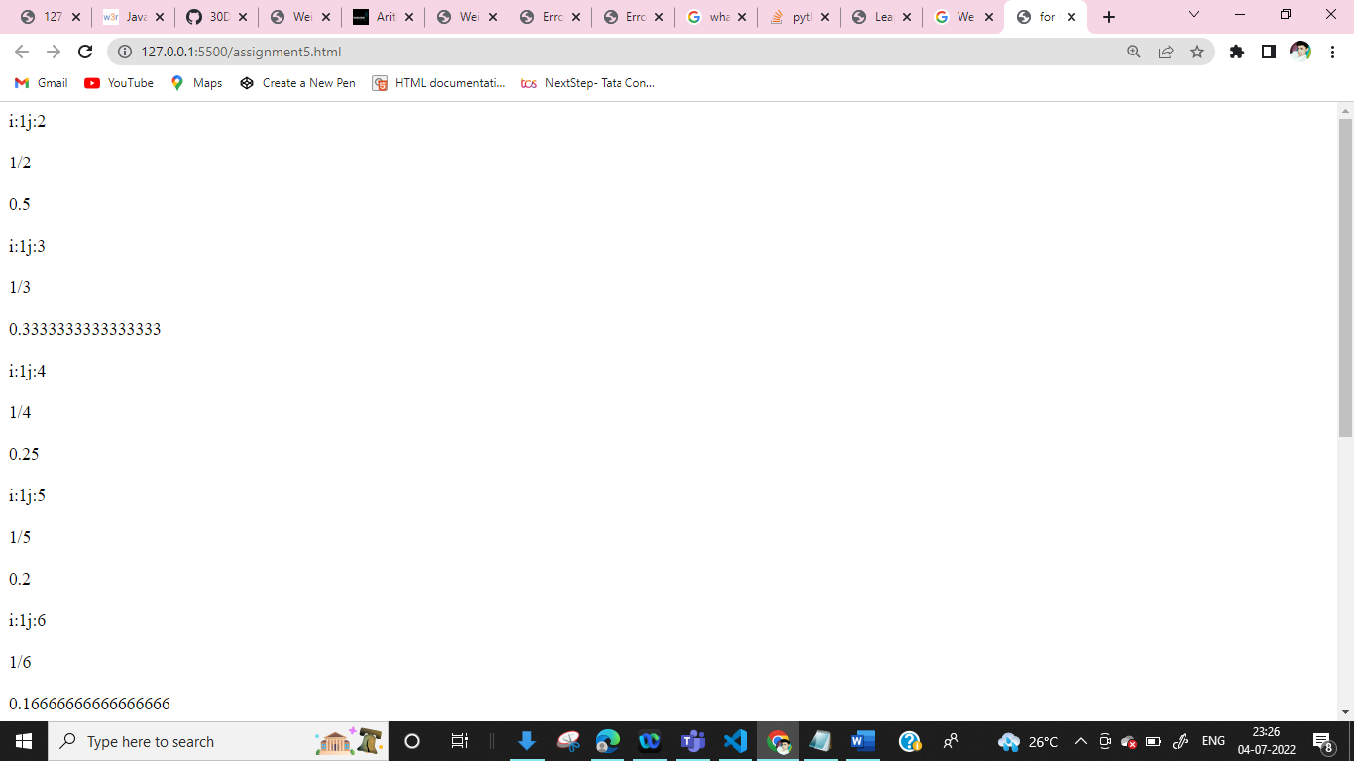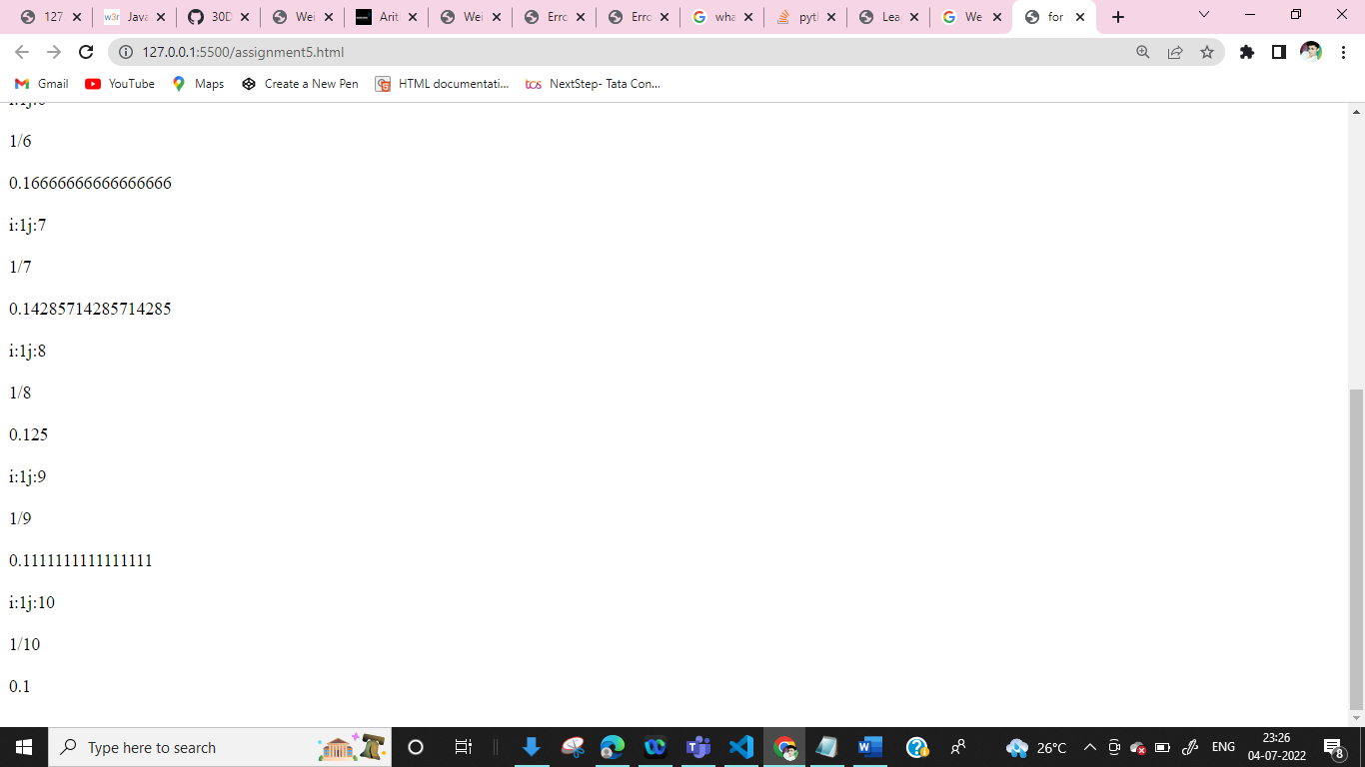

Assignment 6(doubt)

<html>

<head>

<title>Document</title>

</head>

<body>

<script>

var num = parseInt(prompt("Enter number"));

var i= 1

while (i <= 10) {

document.write(i+"<br/>");

i++;

if(num>0)

{

alert("num is positive"+num +"<br/>");

}

else

{

alert("Plz enter a positive nos")

}

}

</script>

</body>

</html>

Assignment 7(doubt)

<html>

<head>

<title>Document</title>

</head>

<body>

<script>

var num

num =parseInt(prompt("Enter your number"))

while (num >= 0){

print(num)

num = num - 1

if(num%2==0)

{

alert("num is divisilbe by "+num)

}

else

{

alert("num it is not divisilbe by "+num)

document.write("plz enter new nos")

}

}

</script>

</body>

</html>

Assignment 8

<html>

<head>

<title>Document</title>

</head>

<body>

<script>

n = 10

i = 10

while (i > 0)

document.write(i)

if (i % 2 == 0)

i = i / 2

else {

i = i + 1

}

<table>

<tr>

<th>X</th>

<th>Num</th>

</tr>

<tr>

<th></th>

</tr>

</table>

</script>

</body>

</html>

Assignment 9(doubt)

<!DOCTYPE html>

<html lang="en">

<head>

<title>Document</title>

</head>

<body>

<script>

function factorial(n) {

if (n == 0)

return 1;

return n \* factorial(n - 1);

}

num = parseInt(prompt("Enter a nos"));

document.write("Factorial of " + num + " is " + factorial(num));

// program to check if a number is prime or not

function prime(n) {

if (number === 1) {

document.write("1 is neither prime nor composite number.");

}

else if (number > 1) {

for (let i = 2; i < number; i++) {

if (number % i == 0) {

isPrime = false;

break;

}

}

if (isPrime) {

document.write(number + "is a prime number");

} else {

document.write(number + " is a not prime number");

}

}

else {

document.write("The number is not a prime number.");

}

}

number = parseInt(prompt("Enter a positive number: "));

document.write(n+ " is " + factorial(number))

</script>

</body>

</html>

Assignment 10

<html lang="en">

<head>

<title>Document</title>

</head>

<body>

<script>

function Triangle(x, y, z)

{

if (x == y && y == z)

document.write("Equilateral Triangle");

else if (x == y || y == z || z == x)

document.write("Isosceles Triangle");

else

document.write("Scalene Triangle");

}

x = parseInt(prompt("x: "))

y = parseInt(prompt("y: "))

z = parseInt(prompt("z: "))

Triangle(x, y, z);

</script>

</body>

</html>

Assignment 11

<html >

<head>

<title>Document</title>

</head>

<body>

<script>

function Triangle(x, y, z)

{

if (x == y && y == z)

document.write("Equilateral Triangle");

else if (x == y || y == z || z == x)

document.write("Isosceles Triangle");

else

document.write("Scalene Triangle");

}

x = parseInt(prompt("x: "))

y = parseInt(prompt("y: "))

z = parseInt(prompt("z: "))

Triangle(x, y, z);

</script>

</body>

</html>

Assignment 13(swap nos)

<html>

<head>

<title>Js program to swap tow numbers two numbers with using third variabkes</title>

</head>

<body>

<script type="text/Javascript">

function swap(a,b,c)

{

var a,b,c

a=prompt("Enter a nos a:")

b=prompt("Enter a nos b:")

c=a

a=b

b=c

document.write("<b>Swap a nos is</b> : "+ a+"<br>")

document.write("<b>Swap b nos is</b> : "+ b+"<br>")

document.write("<b>Swap c nos is</b> : "+ c+"<br>")

}

swap()

</script>

</body>

</html>

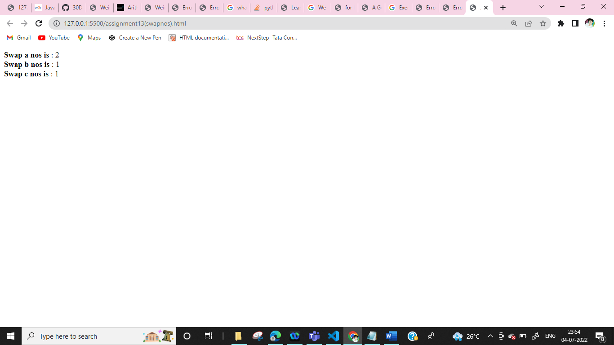

Assignment 13 (without third nos)

<html>

<head>

<title>Js program to swap two numbers two numbers with using third variables</title>

</head>

<body>

<script type="text/Javascript">

function swap(a,b)

{

var a,b

a=parseInt(prompt("Enter a no"));

b=parseInt(prompt("Enter a no"));

a=a+b

b=a-b

a=a-b

document.write("<b>After swap</b> : a="+ a +"<br>" )

document.write("<b>after swap</b> : b="+ b )

}

swap()

</script>

</body>

</html>

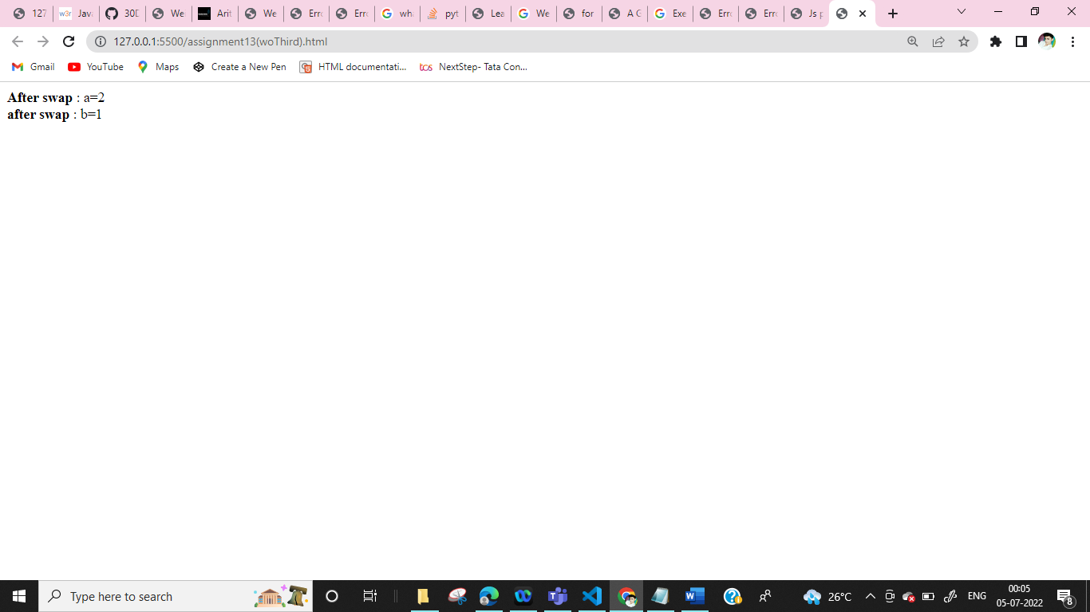

Assignment 13(Simple interest)

<html>

<head>

<title>Js program Simple Interest</title>

</head>

<body>

<script type="text/Javascript">

function simple(p,n,r)

{

var p,n,r,si

p=parseInt(prompt("Enter a nos a:"))

n=parseInt(prompt("Enter a nos a:"))

r=parseInt(prompt("Enter a nos a:"))

si=(p\*n\*r)/100

document.write("<b>p a nos is</b> : "+ p+"<br>")

document.write("<b>n a nos is</b> : "+ n+"<br>")

document.write("<b>r a nos is</b> : "+ r+"<br>")

document.write("<b>Si a nos is</b> : "+ si+"<br>")

}

simple()

</script>

</body>

</html>

